FU9000 Series

This series is split into two sub-series as follows:
FU9000001 to FU9000689
FU9000966 to FU9000999 (continues into the FU9001 series)







PM 29.07.04

PM 29.07.04

RG 29.03.08

JF 15.03.08



User unknown

User unknown

User unknown

User unknown



The Wycliffe Centre

Bodleian Library, Oxford





PM 26.11.07





GSI Westwind


PM 14.12.07

FU9000160
08.09.06
Cancer Research UK



User unknown





PM 07.10.07







PM 25.04.06

PM 05.02.08

User unknown


AN 14.03.08

User unknown

AN 14.03.08

AN 09.10.07

User unknown






PM 06.03.08


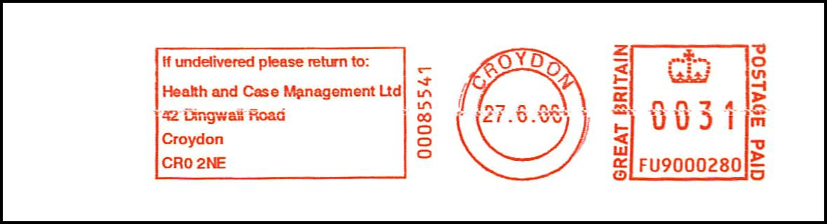



PM 26.07.07




PM 18.03.08

PM 08.02.08



PM 25.02.08



User Unknown



PM 08.02.08



AN 25.03.08



PM 23.03.08

PM 21.03.08




Tuffnells Parcels Express





User unknown



PM 21.02.08

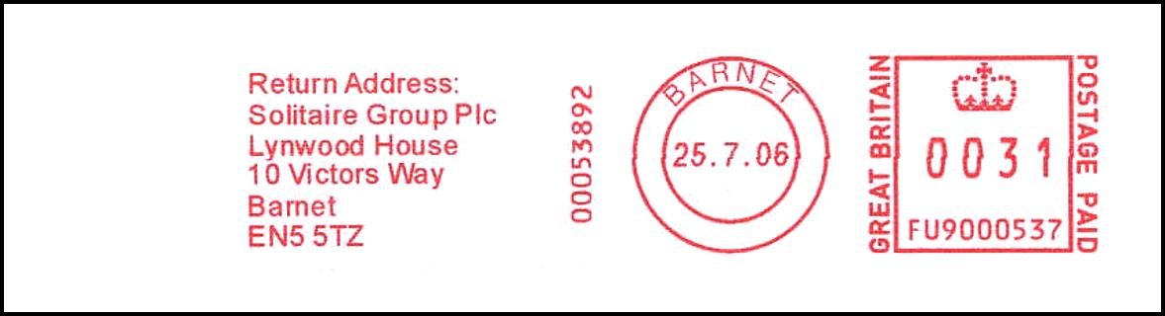

DA 13.10.07













PM 18.03.08

PM 13.10.07



PM 18.03.08

PM 27.02.08




PM 21.03.08

PM 03.03.08



AN 14.03.08


PM 08.02.08

PM 23.03.08

User unknown



